## Discrete Mathematics: Combinatorics

Background

This is a continuation of MAT2612, dealing with counting, relations, functions and partially ordered sets.

**Graph theory**

* isomorphic graphs
* planar graphs
* Euler cycles
* Hamilton circuits
* graph colouring
* trees
* the travelling salesperson problem
* minimal spanning

**Combinatorics**

* basic counting principles
* generating functions
* recurrence relations
* inclusion-exclusion principle.

**Lesson 0**

Introduction to graphs

Simple Graphs are made of two types of objects:

(no loops, multiple edges or directed edges)

Edges - Size

the number of edges in the graph

Vertices - Nodes

Order

the number of vertices in the graph

Sets in this subject follow many of the same principles as ordinary sets (subsets, improper subsets, complimentary sets etc)

[1] Ordered pair with some a finite vertex set V and some Edge set E

[2] Two graphs are equal if they have the same vertex and edge sets

**Lesson 0**

Adjacency

**Adjacent Vertices**

Two vertices are adjacent if they are joined by an edge

Let be a graph and , then and are adjacent in

Let be a graph, then are adjacent in there is an edge in joining a,b

Adjacent Non-adjacent

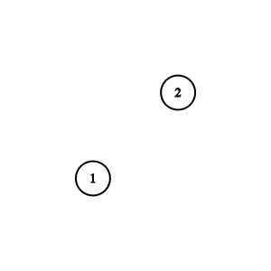

**Adjacent Edges**

Two edges are adjacent if they are incident with a common vertex

Example

bc is incident with the vertex b

ab is incident with the vertex b

ab is adjacent to bc

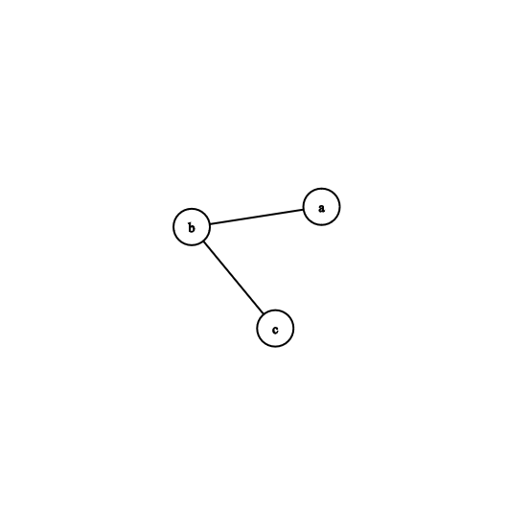

Example

ab is adjacent to bc

bc is adjacent to cd

cd is adjacent to ad

ab is adjacent to bc

**Isolated Vertices**

A vertex is isolated if it not joined by any edge

**Lesson 0**

Degree of a Vertex

The degree of a vertex is the number of edges incident to it

*The number of vertices adjacent to it*

**Lesson 0**

The empty graph, trivial graph, and null graph

Example: empty graph

Empty Graph is any graph with some empty Edge set E

*The complement of the complete graph on 2 vertices*



Example: trivial graph

*The empty graph on 1 vertex*

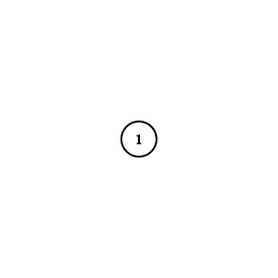

Example: null graph

(Sometimes called the empty graph)

*No vertices. No edges. Is sometimes a graph, sometimes not*

**Lesson 0**

Subgraphs

* *the vertex set of H is the subset of vertex set of G AND*
* *the edge set of H is the subset of edge set of G*

Every graph is also a subgraph of itself (improper subgraph)

Example: Which of the graphs is a subgraph of another?

Spanning subgraph

* *the vertex set of H is equal to the subset of vertex set of G AND*
* *the edge set of H is the subset of edge set of G*

Example: Which of the graphs is a spanning subgraph of another?

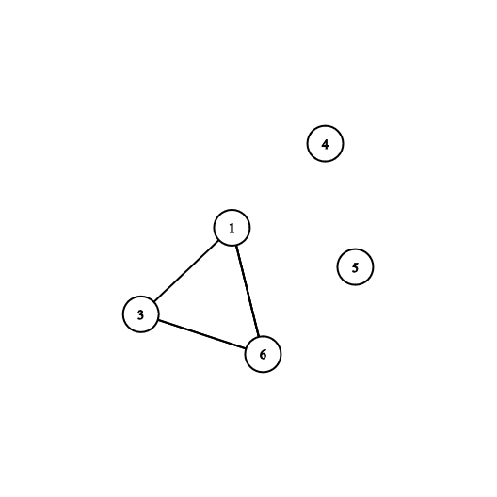

**Lesson 0**

Proper and Improper Subgraphs

Proper subset

Improper subset

**Lesson 1**

Degree sequence

- basic definitions & properties of graphs

(simple mathematical models of networks)

- modelling of real-life problems in terms of graphs

- isomorphism

- special types of graphs: connected graphs

- special types of graphs: bipartite graphs